Model-View-ViewModel (MVVM)
# Source: AI Source: Provided by: [Data Path: Persons Table -> ID Column: 1, Name_En Column: Motasem Essam] -> From: [ChatGPT] on [1/23/2026]
Model-View-ViewModel (MVVM) is an architectural pattern that separates an application into Model, View, and ViewModel, with a focus on data binding and UI state management.
👉 Think of it like:
- Model = Data & business logic
- View = UI
- ViewModel = bridge that prepares data for the View

🔑 Key Idea
# Source: AI Source: Provided by: [Data Path: Persons Table -> ID Column: 1, Name_En Column: Motasem Essam] -> From: [ChatGPT] on [1/23/2026]
The View does not talk directly to the Model
👉 It communicates through the ViewModel

🧱 Structure
# Source: AI Source: Provided by: [Data Path: Persons Table -> ID Column: 1, Name_En Column: Motasem Essam] -> From: [ChatGPT] on [1/23/2026]
View ↔ ViewModel ↔ Model
- View → Displays data and observes changes
- ViewModel → Holds UI logic and state
- Model → Business logic and data

🧩 Example

Model
# Source: AI Source: Provided by: [Data Path: Persons Table -> ID Column: 1, Name_En Column: Motasem Essam] -> From: [ChatGPT] on [1/23/2026]
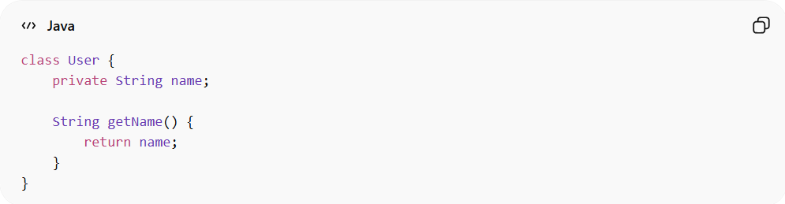
class User {
private String name;

String getName() {
return name;
}
}

ViewModel
# Source: AI Source: Provided by: [Data Path: Persons Table -> ID Column: 1, Name_En Column: Motasem Essam] -> From: [ChatGPT] on [1/23/2026]
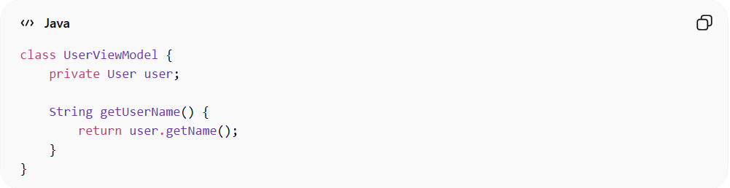
class UserViewModel {
private User user;

String getUserName() {
return user.getName();
}
}

View
# Source: AI Source: Provided by: [Data Path: Persons Table -> ID Column: 1, Name_En Column: Motasem Essam] -> From: [ChatGPT] on [1/23/2026]
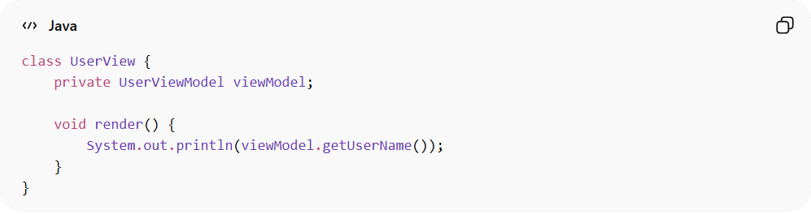
class UserView {
private UserViewModel viewModel;

void render() {
System.out.println(viewModel.getUserName());
}
}

❌ Bad Example (Without MVVM)
# Source: AI Source: Provided by: [Data Path: Persons Table -> ID Column: 1, Name_En Column: Motasem Essam] -> From: [ChatGPT] on [1/23/2026]
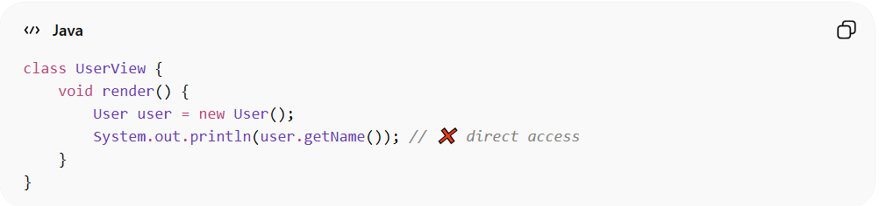
class UserView {
void render() {
User user = new User();
System.out.println(user.getName()); // ❌ direct access
}
}
👉 Problems:
- UI directly depends on Model
- Hard to test and maintain

🌍 Real Example of MVVM
# Source: AI Source: Provided by: [Data Path: Persons Table -> ID Column: 1, Name_En Column: Motasem Essam] -> From: [ChatGPT] on [1/23/2026]
Imagine you’re building a mobile app (Android/iOS) that shows a user profile.

🧱 How MVVM Works in Real Life

1️⃣ Model (Data Layer)
# Source: AI Source: Provided by: [Data Path: Persons Table -> ID Column: 1, Name_En Column: Motasem Essam] -> From: [ChatGPT] on [1/23/2026]
Represents data coming from API or database
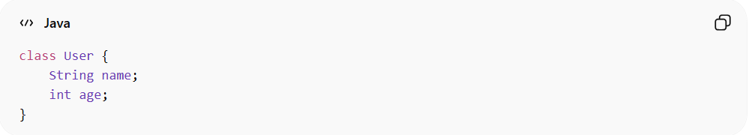
class User {
String name;
int age;
}

2️⃣ ViewModel (Logic + State)
# Source: AI Source: Provided by: [Data Path: Persons Table -> ID Column: 1, Name_En Column: Motasem Essam] -> From: [ChatGPT] on [1/23/2026]
Prepares data for UI and handles logic
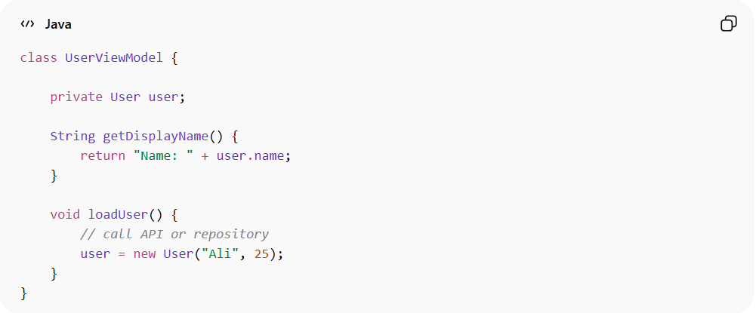
class UserViewModel {

private User user;

String getDisplayName() {
return "Name: " + user.name;
}

void loadUser() {
// call API or repository
user = new User("Ali", 25);
}
}

3️⃣ View (UI Layer)
# Source: AI Source: Provided by: [Data Path: Persons Table -> ID Column: 1, Name_En Column: Motasem Essam] -> From: [ChatGPT] on [1/23/2026]
Displays data and observes ViewModel
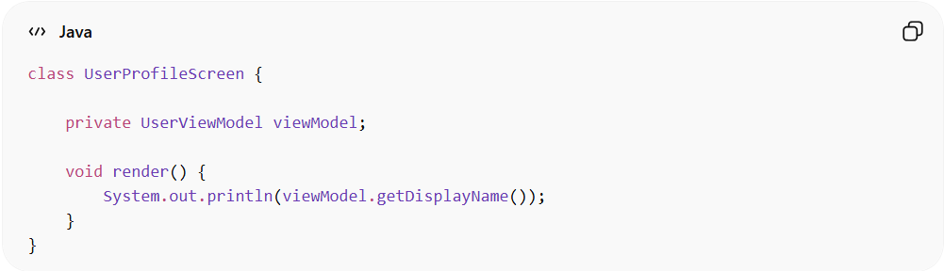
class UserProfileScreen {

private UserViewModel viewModel;

void render() {
System.out.println(viewModel.getDisplayName());
}
}

🔄 Real Flow (Step by Step)
# Source: AI Source: Provided by: [Data Path: Persons Table -> ID Column: 1, Name_En Column: Motasem Essam] -> From: [ChatGPT] on [1/23/2026]
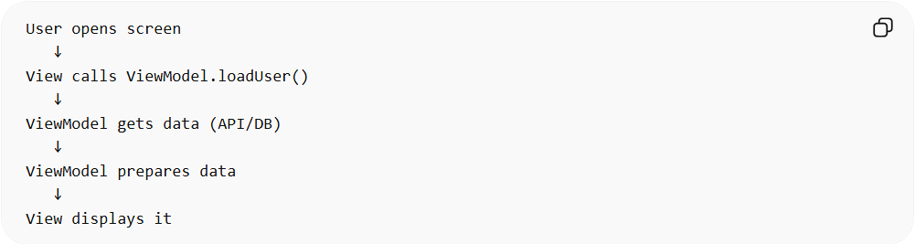
User opens screen
↓
View calls ViewModel.loadUser()
↓
ViewModel gets data (API/DB)
↓
ViewModel prepares data
↓
View displays it

📱 Real Framework Examples

Android (Very Common)
# Source: AI Source: Provided by: [Data Path: Persons Table -> ID Column: 1, Name_En Column: Motasem Essam] -> From: [ChatGPT] on [1/23/2026]
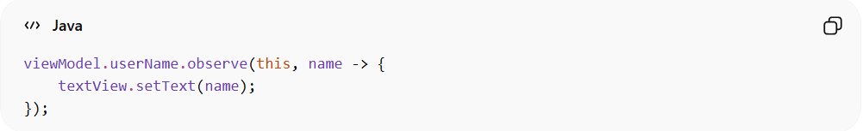
- Uses LiveData / ViewModel
- UI automatically updates when data changes
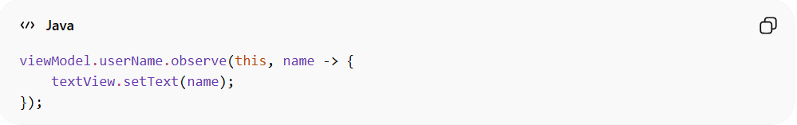
viewModel.userName.observe(this, name -> {
textView.setText(name);
});

Web (React Example)
# Source: AI Source: Provided by: [Data Path: Persons Table -> ID Column: 1, Name_En Column: Motasem Essam] -> From: [ChatGPT] on [1/23/2026]
- ViewModel = State (useState / Redux)
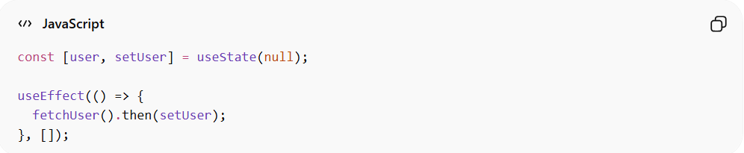
const [user, setUser] = useState(null);

useEffect(() => {
fetchUser().then(setUser);
}, []);
👉 React state acts like ViewModel

Angular
# Source: AI Source: Provided by: [Data Path: Persons Table -> ID Column: 1, Name_En Column: Motasem Essam] -> From: [ChatGPT] on [1/23/2026]
- Uses Services + Observables
- Template automatically updates
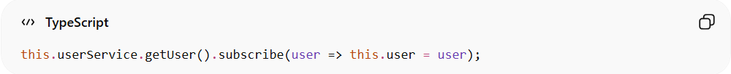
this.userService.getUser().subscribe(user => this.user = user);

❌ Without MVVM (Real Problem)
# Source: AI Source: Provided by: [Data Path: Persons Table -> ID Column: 1, Name_En Column: Motasem Essam] -> From: [ChatGPT] on [1/23/2026]
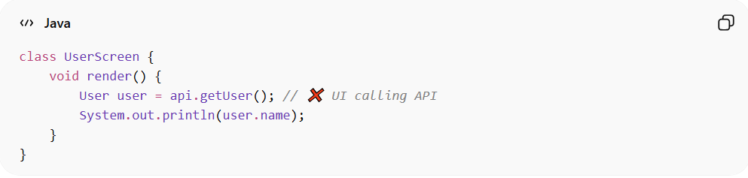
class UserScreen {
void render() {
User user = api.getUser(); // ❌ UI calling API
System.out.println(user.name);
}
}
👉 Problems:
- UI tightly coupled to data
- Hard to test
- Hard to reuse logic

✅ With MVVM (Real Benefit)
# Source: AI Source: Provided by: [Data Path: Persons Table -> ID Column: 1, Name_En Column: Motasem Essam] -> From: [ChatGPT] on [1/23/2026]
- UI does NOT know about API
- Logic is reusable
- Easy to test ViewModel alone

💡 Simple Analogy
# Source: AI Source: Provided by: [Data Path: Persons Table -> ID Column: 1, Name_En Column: Motasem Essam] -> From: [ChatGPT] on [1/23/2026]
- Model = Database / API
- ViewModel = Translator / middleman
- View = Screen user sees

🧾 Summary
# Source: AI Source: Provided by: [Data Path: Persons Table -> ID Column: 1, Name_En Column: Motasem Essam] -> From: [ChatGPT] on [1/23/2026]
MVVM is used everywhere in modern apps where UI needs to react to data changes automatically

✅ Benefits
# Source: AI Source: Provided by: [Data Path: Persons Table -> ID Column: 1, Name_En Column: Motasem Essam] -> From: [ChatGPT] on [1/23/2026]
- Clear separation between UI and logic
- Easier unit testing (ViewModel is testable)
- Supports data binding (auto UI updates)
- Better for modern UI frameworks

⚠️ Drawbacks
# Source: AI Source: Provided by: [Data Path: Persons Table -> ID Column: 1, Name_En Column: Motasem Essam] -> From: [ChatGPT] on [1/23/2026]
- More complexity than MVC for small apps
- Requires understanding of data binding
- More layers → more setup

⚡ When to Use
# Source: AI Source: Provided by: [Data Path: Persons Table -> ID Column: 1, Name_En Column: Motasem Essam] -> From: [ChatGPT] on [1/23/2026]
- Modern frontend frameworks (Angular, React with state management)
- Mobile apps (Android, iOS)
- Applications with dynamic UI updates

🔄 MVC vs MVVM (Quick Idea)
# Source: AI Source: Provided by: [Data Path: Persons Table -> ID Column: 1, Name_En Column: Motasem Essam] -> From: [ChatGPT] on [1/23/2026]
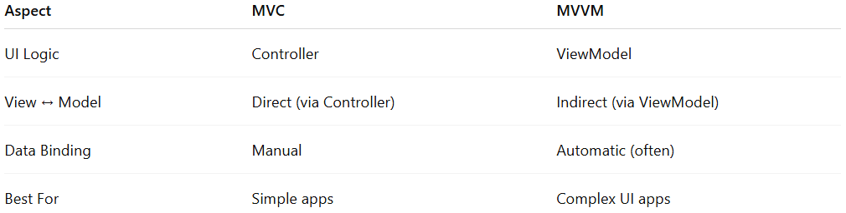
Aspect | MVC | MVVM
UI Logic | Controller | ViewModel
View ↔ Model | Direct (via Controller) | Indirect (via ViewModel)
Data Binding | Manual | Automatic (often)
Best For | Simple apps | Complex UI apps

💡 Key Idea
# Source: AI Source: Provided by: [Data Path: Persons Table -> ID Column: 1, Name_En Column: Motasem Essam] -> From: [ChatGPT] on [1/23/2026]
MVVM improves on MVC by introducing a ViewModel that handles UI logic and state, making the UI cleaner and more reactive

🧾 Summary
# Source: AI Source: Provided by: [Data Path: Persons Table -> ID Column: 1, Name_En Column: Motasem Essam] -> From: [ChatGPT] on [1/23/2026]
MVVM separates your app into:
- Model → Data
- View → UI
- ViewModel → UI logic & state
👉 Result: testable, scalable, and reactive UI applications

